AsanDoc: guidelines for signing
Signing e-documents with “AsanDoc”: Microsoft Windows
Signing e-documents with “AsanDoc”: MAC
Singing e-documents with “AsanDoc”: Linux
Signing e-documents with “AsanDoc”: Android
Signing e-documents with “AsanDoc”: iOS

Signing e-documents with “AsanDoc”:

Microsoft Windows
1. Open “AsanDoc” in your computer:
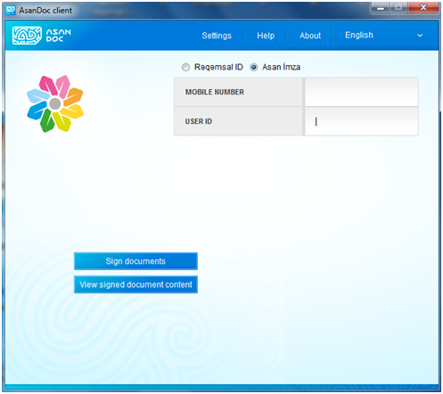
2. Press the button “Sign documents” and choose a file you want to sign:
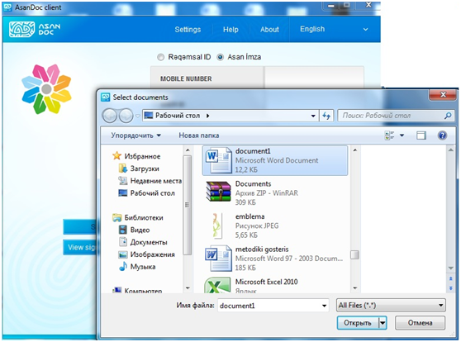
3. After selecting the file, a window opens to save the created AsanDoc file (* .adoc). In this window you can change the name and location of the AsanDoc file:
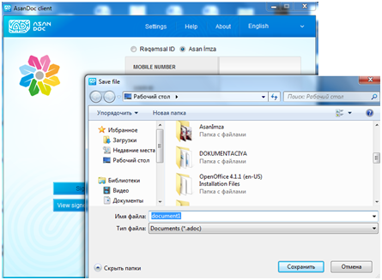
4. File to be signed added to the container of “AsanDoc”:
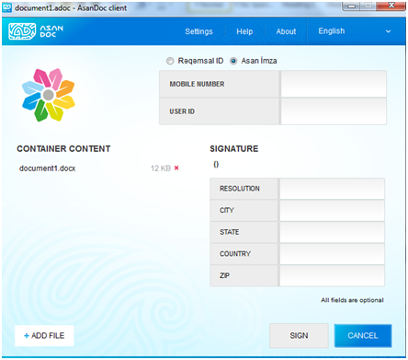
5. For signing the file enter in the “Mobile number” field the number on which the “Asan İmza” service is active. Enter in the “User ID” field a six-digit “Asan İmza” user ID. After you complete these fields, the button “Sign” will become active. Also you can fill the optional fields “Resolution” , “City”, “State”, “Country”, “ZIP”:
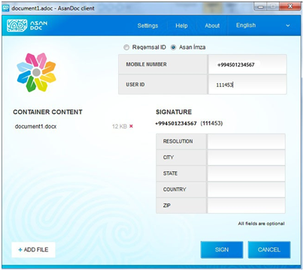
6. If you have not used before the “Asan İmza” mobile e-signature to sign documents with “AsanDoc”, you will be prompted to download an access token for the mobile e-signature service. In this case, select the “Yes” button:
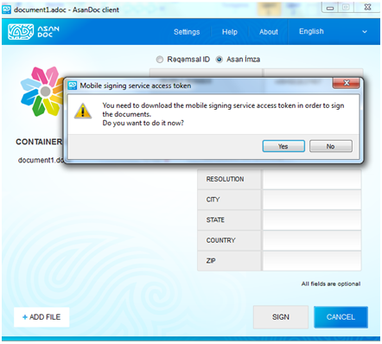
7. To download the token, it is necessary to use the “Asan İmza”mobile e-signature. Make sure the verification code on the computer screen matches with the code on your mobile phone and enter the Asan İmza PIN1 on your phone:
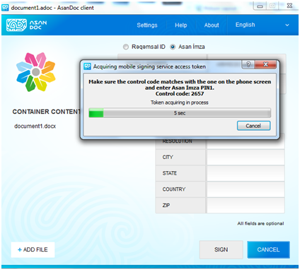 | 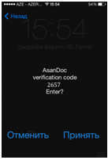
8. You will receive a message about installing of the access token for the mobile e-signature service. In this window, select the button “Continue signing”:
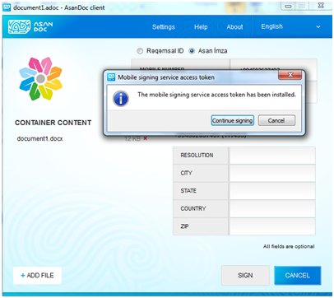
9. A window appears with a list of your digital certificates. Select the certificate required for the signing operation and confirm by pressing “OK” (in this example, an individual certificate is selected) * :
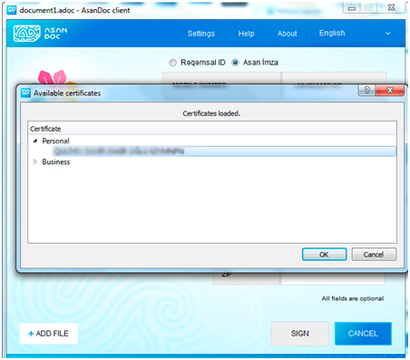
10. Make sure the verification code on the computer screen matches with the code on your mobile phone and enter the Asan İmza PIN2:
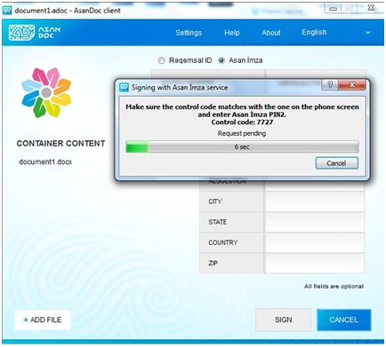 | 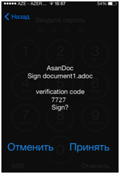
11. Finally, the file is signed with “AsanDoc”. By pressing the button “Show details” you can get detailed information about the parameters of the electronic signature.
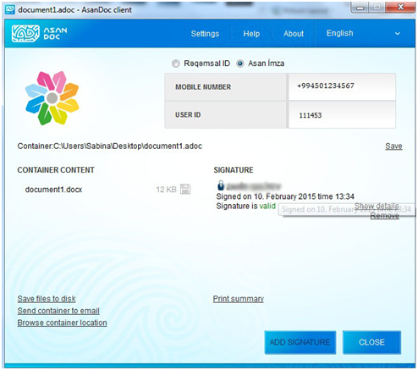
12. You can see the folder where you saved the file signed with “AsanDoc”. This file can be used accordingly (i.e sent via e-mail, print etc.).
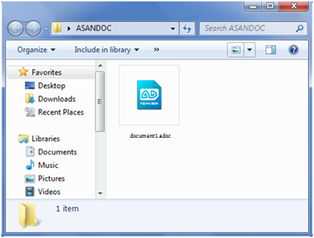

Signing e-documents with “AsanDoc”: MAC
1. Open “AsanDoc” in your computer:
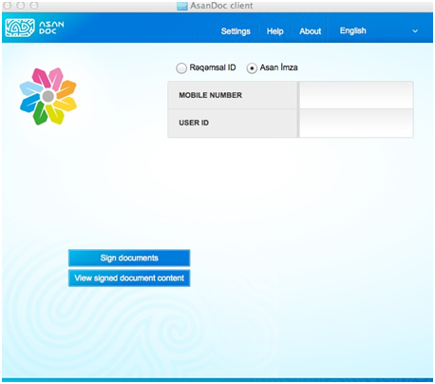
2. Press the button “Sign documents” and choose a file you want to sign:
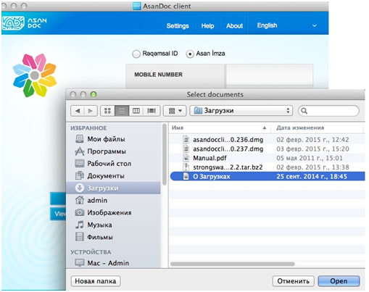
3. After selecting the file, a window opens to save the created AsanDoc file (* .adoc). In this window you can change the name and location of the file AsanDoc:
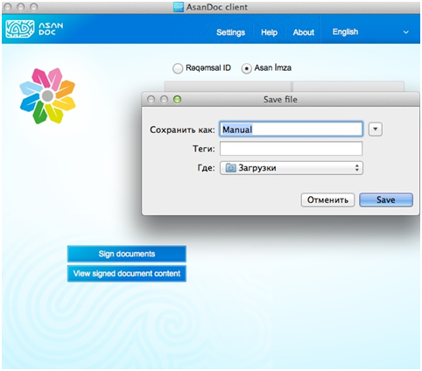
4. File to be signed added to the container of “AsanDoc”:
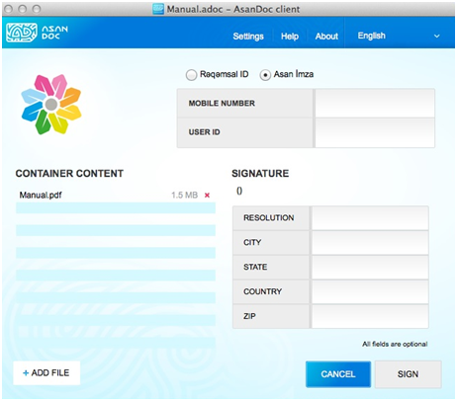
5. For signing the file enter in the “Mobile number” field the number on which the “Asan İmza” service is active. Enter in the “User ID” field a six-digit “Asan İmza” user ID. After you complete these fields, the button “Sign” will become active. Also you can fill the optional fields “Resolution” , “City”, “State”, “Country”, “ZIP”:
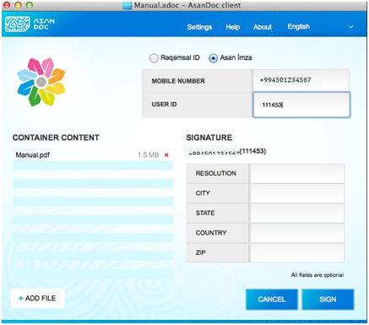
6. If you have not used before the “Asan İmza” mobile e-signature to sign documents with “AsanDoc”, you will be prompted to download an access token for the mobile e-signature service. In this case, select the “Yes” button:
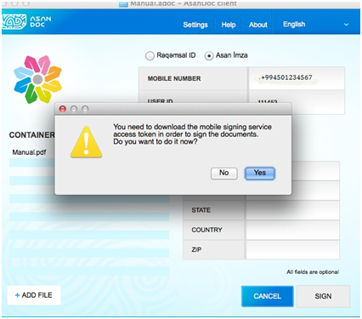
7. To download the token, it is necessary to use the “Asan İmza”mobile e-signature. Make sure the verification code on the computer screen matches with the code on your mobile phone and enter the Asan İmza PIN1 on your phone:
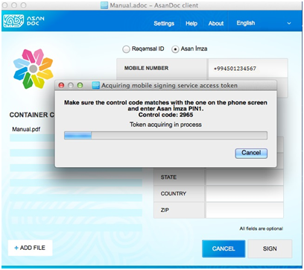 | 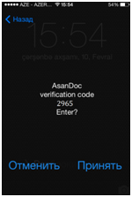
8. You will receive a message about installing of the access token for the mobile e-signature service. In this window, select the button “Continue signing”:
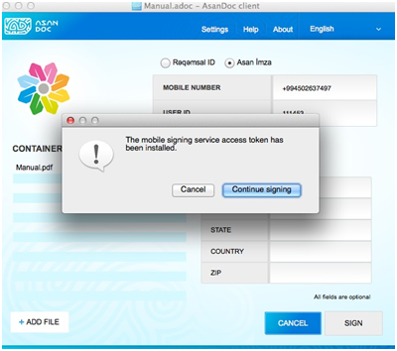
9. A window appears with a list of your digital certificates. Select the certificate required for the signing operation and confirm by pressing “OK” (in this example, an individual certificate is selected) ** :
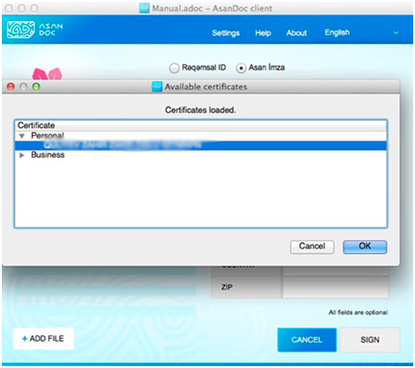
10. Make sure the verification code on the computer screen matches with the code on your mobile phone and enter the Asan İmza PIN2:
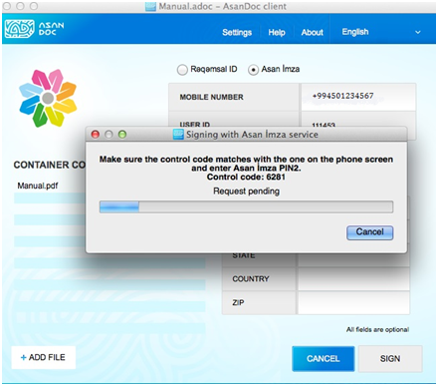 | 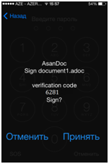
11. Finally, the file is signed with “AsanDoc”. By pressing the button “Show details” you can get detailed information about the parameters of the electronic signature:
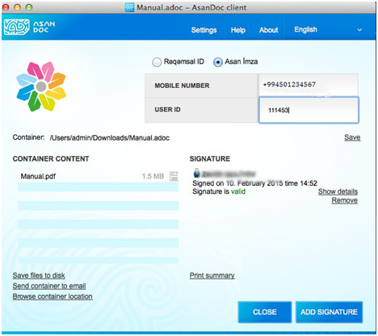
12. You can see the folder where you saved the file signed with “AsanDoc”. This file can be used accordingly (i.e sent via e-mail, print etc.):
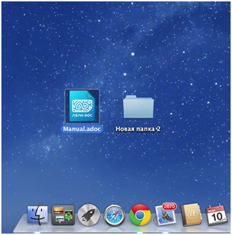

Signing e-documents with “AsanDoc”: Linux
1. Open “AsanDoc” in your computer:
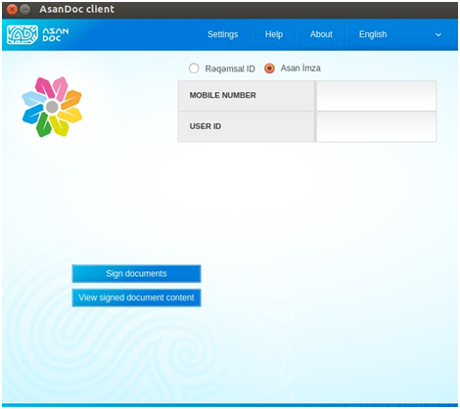
2. Press the button “Sign documents” and choose a file you want to sign:
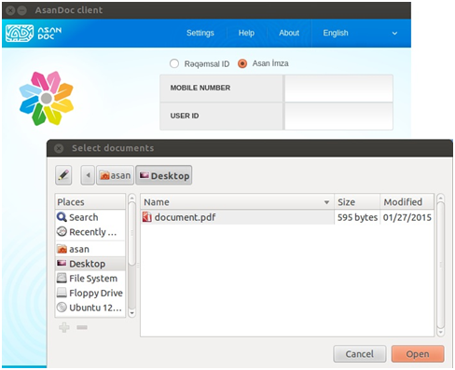
3. After selecting the file, a window opens to save the created AsanDoc file (* .adoc). In this window you can change the name and location of the file AsanDoc:
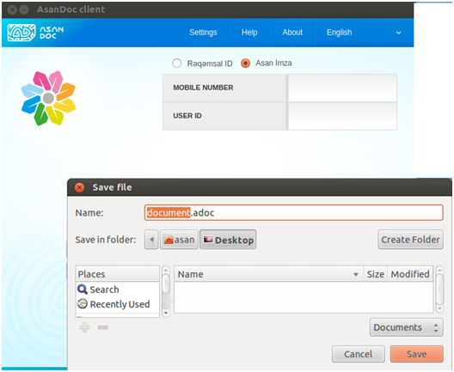
4. File to be signed added to the container of “AsanDoc”:
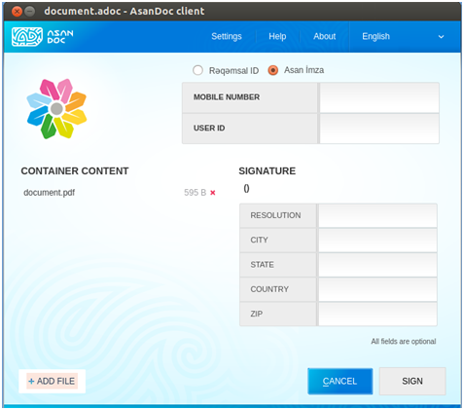
5. For signing the file enter in the “Mobile number” field the number on which the “Asan İmza” service is active. Enter in the “User ID” field a six-digit “Asan İmza” user ID. After you complete these fields, the button “Sign” will become active. Also you can fill the optional fields “Resolution” , “City”, “State”, “Country”, “ZIP”:
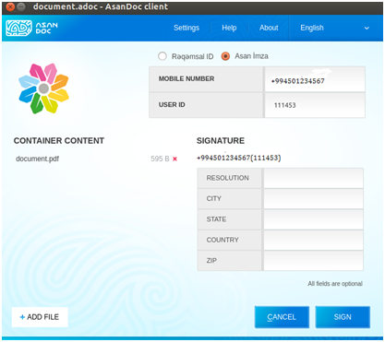
6. If you have not used before the “Asan İmza” mobile e-signature to sign documents with “AsanDoc”, you will be prompted to download an access token for the mobile e-signature service. In this case, select the “Yes” button:
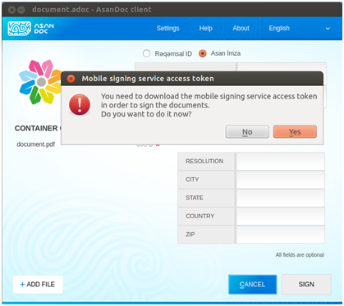
7. To download the token, it is necessary to use the “Asan İmza”mobile e-signature. Make sure the verification code on the computer screen matches with the code on your mobile phone and enter the Asan İmza PIN1 on your phone:
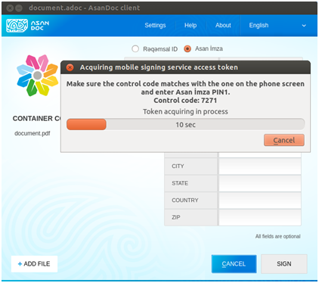 | 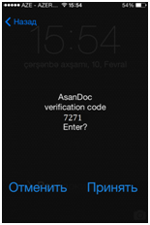
8. You will receive a message about installing of the access token for the mobile e-signature service. In this window, select the button “Continue signing”:
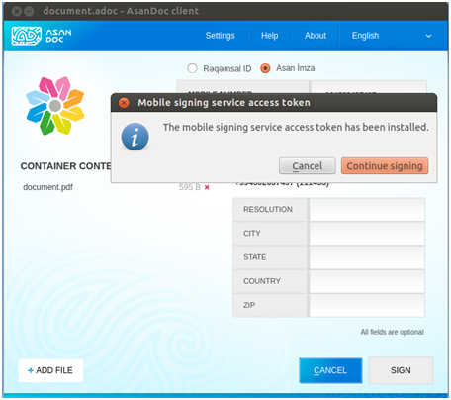
9. A window appears with a list of your digital certificates. Select the certificate required for the signing operation and confirm by pressing “OK” (in this example, an individual certificate is selected) *** :
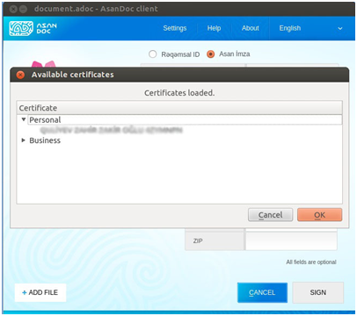
10. Make sure the verification code on the computer screen matches with the code on your mobile phone and enter the Asan İmza PIN2:
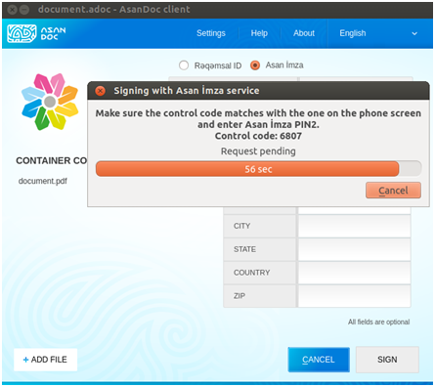 | 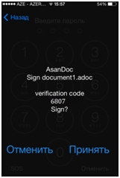
11. Finally, the file is signed with “AsanDoc”. By pressing “Show details” you can get detailed information about the parameters of the electronic signature:
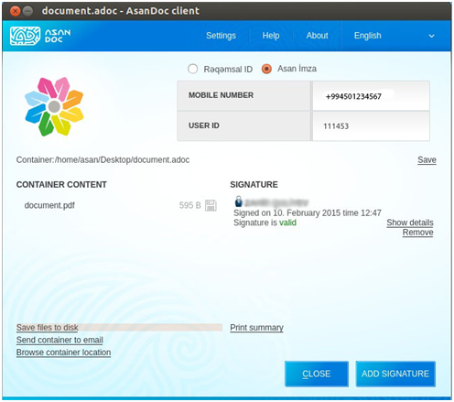
12. You can see the folder where you saved the file signed with “AsanDoc”. This file can be used accordingly (i.e sent via e-mail, print etc.):
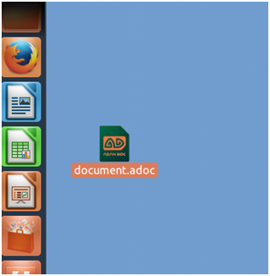

Signing e-documents with “AsanDoc”: Android
1. Download “AsanDoc” from “Google Play Market”.URL for download

2. Enter the program and select a file you want to sign:
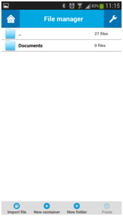 | 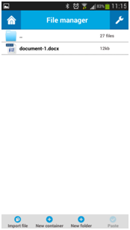
3. For signing the file enter in the “Mobile number” field the number on which the “Asan İmza” service is active. Enter in the “User ID” field a six-digit “Asan İmza” user ID. After you complete these fields, the button “Sign” will become active. Also you can fill the optional fields “Role/Resolution” , “City “, “State/Province”, “Country”, “Postal code”:
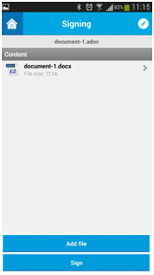 | 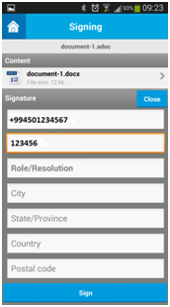
4. Make sure the verification code on the program’s screen matches with the code on your mobile phone and enter the Asan İmza PIN1:
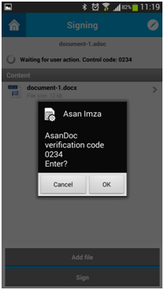 | 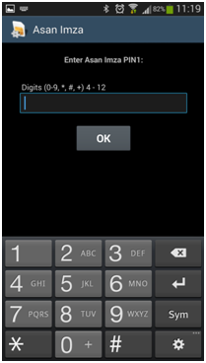
5. A window appears with a list of your digital certificates. Select the certificate required for the signing operation (in this example, an individual certificate is selected):
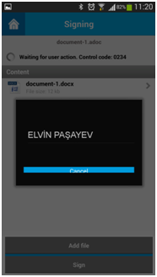 | 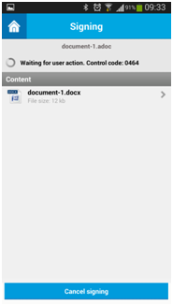
6. Make sure the verification code on the program’s screen matches with the code on your mobile phone and enter the Asan İmza PIN2:
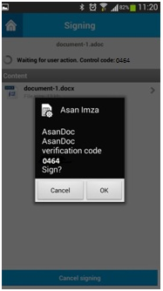 | 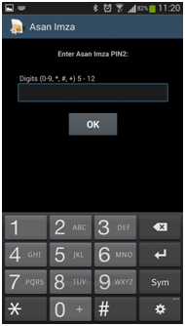
7. Finally, the file is signed with “AsanDoc”. The signed document can be used accordingly (i.e. sent via email, printed etc.).
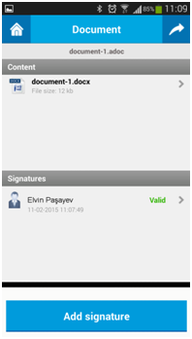

Signing document with “AsanDoc”: iOS
1. Download “AsanDoc“ from “Apple Store”.URL for downloading
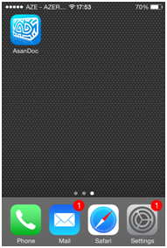
2. Select a file you want to sign with “AsanDoc”. The file to be signed will be added to the container of “AsanDoc”:
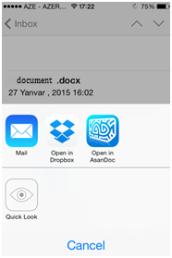 | 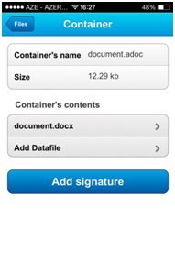
3. For signing the file enter in the “Phone number” field the number on which the “Asan İmza” service is active. Enter in the “User ID” field a six-digit “Asan İmza” user ID. After you complete these fields, the button “Add signature” will become active. Also you can fill the optional fields “Role ” , “City “, “State “, “Country”, “Index”:
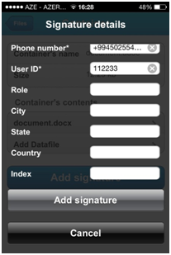
4. Make sure the verification code on the program’s screen matches with the code on your mobile phone and enter the Asan İmza PIN1:
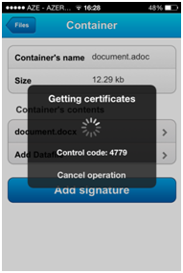 | 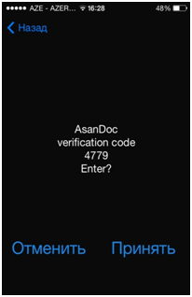 | 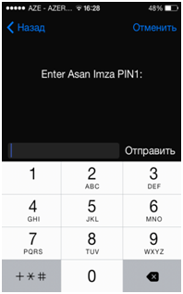
5. A window appears with a list of your digital certificates. Select the certificate required for the signign operation (in this example, an individual certificate is selected):
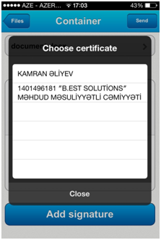
6. Make sure the verification code on the program’s screen matches with the code on your mobile phone and enter the Asan İmza PIN2:
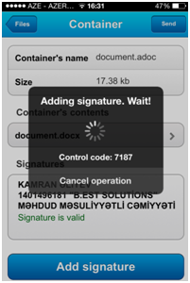 | 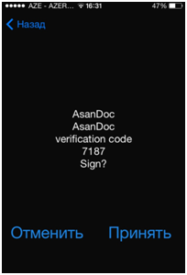 | 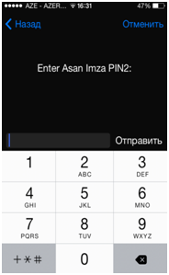
7. Finally, the file is signed with “AsanDoc”. The signed document can be used accordingly (i.e. sent via email, printed etc.):
